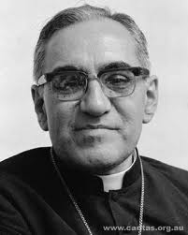
Name: ______________________
Date: ________________________

Antigone- Rebels Project

Objective
You will research a modern-day rebel who embodies the same traits as Antigone. You will create a poster board with images and brief write-ups, and give a 2-3 minute informative speech on your rebel.
Total: 50 points.
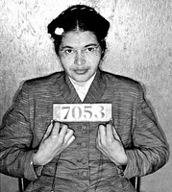
Details
Choose a person who has broken laws for moral reasons, pushed boundaries, or stood up to those in power to make a statement. This rebel must have lived during the past 100 years and made significant contributions to society. You may choose any figure that you want, but you must have this person approved by me.

Your poster board, PowerPoint, iMovie, Prezi etc. should display at least 2 images of your modern-day rebel. Also, you must include a brief summary of the rebel’s life and one paragraph comparing the rebel to Antigone. Be creative in your presentation! Visual: 25 points.

In class, you will give a 2-3 minute informative speech on your modern-day rebel. Focus on his/her specific actions and what he/she stood for. Clearly explain at least 2 similarities between your rebel and Antigone. You may use notecards for your speech. Your speech will be timed. Speech: 25 points.

Possible Modern-Day Rebels to Research
Malcolm X (human rights activist)
Rosa Parks (“first lady of civil rights movement”)
Pope John Paul II (advocate for human rights)
Oscar Romero spoke out against poverty, social injustice, assassinations and torture)
Mahatma Gandhi (nonviolent civil disobedience)
Mother Teresa (missionary)
Nelson Mandela (anti-aparteid revolutionary / President of South Africa)
Harvey Milk (gay politician in California in 1970s)
Alexander McQueen (British Fashion Designer)
Lady Gaga (pop star)
Kurt Cobain (lead singer of Nirvana)
Janis Joplin (lead singer of rock band)
Eminem (rapper)
Matisyahu (Jewish reggae artist)
Leymah Roberta Gbowee (African Peace Activist)
Ani Pachen (Tibetan Buddhist who led guerilla rebellion)
Annie Liebovitz (iconic photographer)
Dietrich Bonhoeffer (founding member of the confessing church)

Name: ___________________________________ Modern Day Rebel: _________________________________

Visual

Criteria | Possible Points | Comments
Two images of your Rebel | /5
Summary of Rebel’s Life | /5
One Paragraph Comparison to Antigone | /10
Creativity | /5

Visual Total: _________ / 25

Speech

Criteria | Possible Points | Comments
Time of 2-3 minutes | /5
Discussion of rebel’s actions & power | /5
Identify what your Rebel stood for | /5
2 similarities between Rebel and Antigone | /10

Speech Total: ___________ / 25

TOTAL PROJECT GRADE: ____________ / 50

