Name_______________________
Ms. Marciano

Good natured humor; jolly = jovial

Noisy; high spirited = boisterous

Given freely; lavishly = profusely
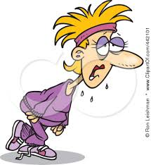
Date__________________
Period ________________

Equipment used for a particular purpose or activity = paraphernalia
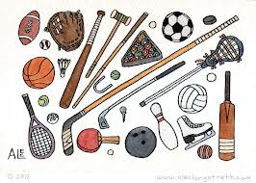

Unenthusiastic; disinterested = perfunctory
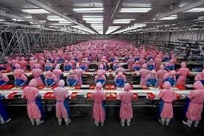

Name ______________________ Date __________________
Ms. Marciano Period _________________

“The Lottery” – Vocabulary

Directions: Using the next page as a guide, complete the chart below.

Word | Definition | Sentence

